**Project Design Phase-II**

**Data Flow Diagram & User Stories**

|  |  |
| --- | --- |
| Date | 14 October 2022 |
| Team ID | PNT2022TMID44607 |
| Project Name | Project – Global sales data analytics |
| Maximum Marks | 4 Marks |

**Data Flow Diagrams:**

A Data Flow Diagram (DFD) is a traditional visual representation of the information flows within a system. A neat and clear DFD can depict the right amount of the system requirement graphically. It shows how data enters and leaves the system, what changes the information, and where data is stored.

**Example:**

[**(**](https://developer.ibm.com/patterns/visualize-unstructured-text/)

[**Simplified**](https://developer.ibm.com/patterns/visualize-unstructured-text/)

[**)**](https://developer.ibm.com/patterns/visualize-unstructured-text/)

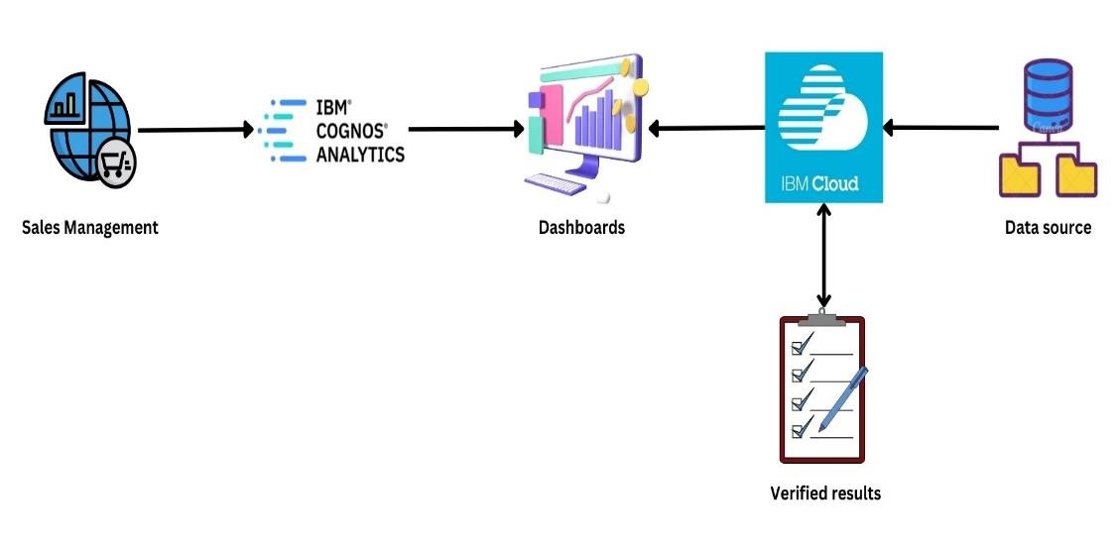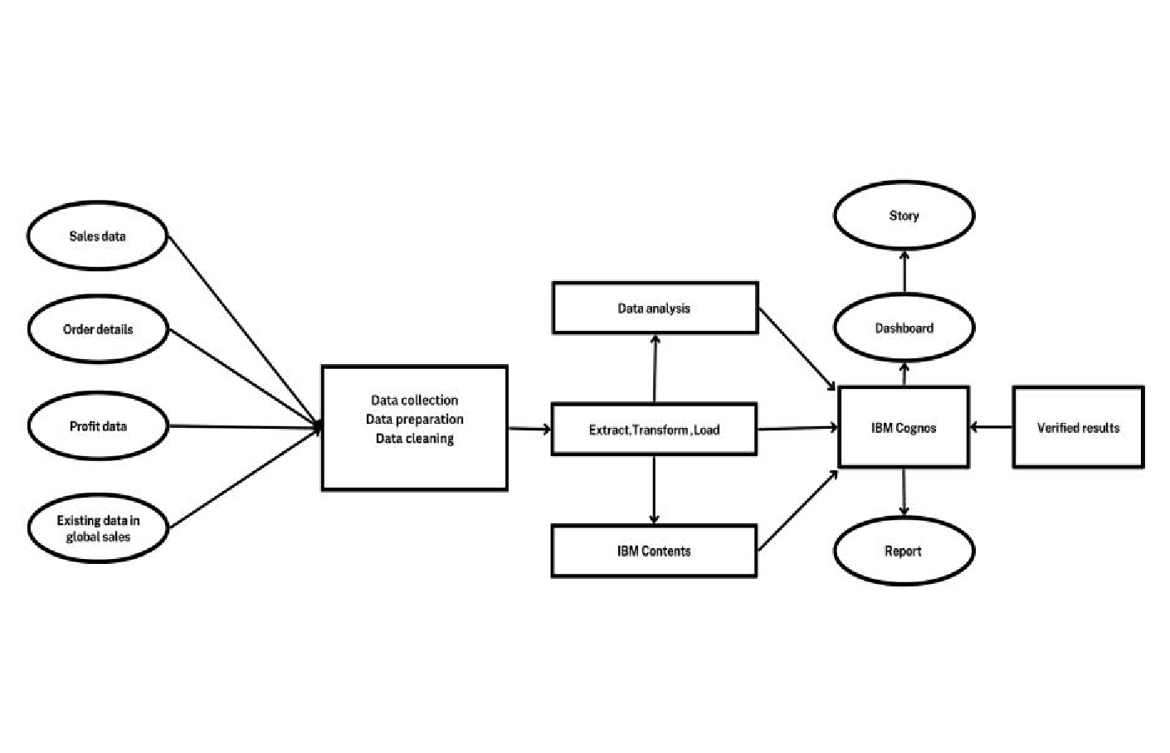

Example: DFD Level 0 (Industry Standard)

**User Stories**

|  |  |  |  |  |  |  |
| --- | --- | --- | --- | --- | --- | --- |
| **User Type** | **Functional**  **Requirement**  **(Epic)** | **User Story Number** | **User Story / Task** | **Acceptance criteria** | **Priority** | **Release** |
| Sales analyst/Customer | User Registration | USN-1 | As a user, I can register for the application by entering my email, password, and confirming my password. | I can get the details of customer based on Requirements. | High | Sprint-1 |
| As a user, I will receive confirmation email once I have registered for the application | High | Sprint-1 |
| Login | USN-2 | As a user, I will log in to the desired application using login credentials. | I can get the order details, sales and profit  dashboards, reports, and  stories used for customer analysis and product analysis. | Low | Sprint-2 |
| Dashboards | USN-3 | As a sales analyst/customer, I can view the important sales and profit of the products and other information in real-time. | High | Sprint-1 |
| Administrator |  | USN-4 | As an administrator, I can access the database of the customers, sales reports, and a secure interface. | Customer relationship is managed and responsible for maintaining, updating the data. | High | Sprint-2 |